**Exercise 1: Configuring a Basic Spring Application**

**Scenario:**

Your company is developing a web application for managing a library. You need to use the Spring Framework to handle the backend operations.

Steps:

1. Set Up a Spring Project:

o Create a Maven project named LibraryManagement.

o Add Spring Core dependencies in the pom.xml file.

2. Configure the Application Context:

o Create an XML configuration file named applicationContext.xml in the src/main/resources directory.

o Define beans for BookService and BookRepository in the XML file.

3. Define Service and Repository Classes:

o Create a package com.library.service and add a class BookService.

o Create a package com.library.repository and add a class BookRepository.

4. Run the Application:

o Create a main class to load the Spring context and test the configuration.

**Pom.xml:**

<project xmlns="http://maven.apache.org/POM/4.0.0"

xmlns:xsi="http://www.w3.org/2001/XMLSchema-instance"

xsi:schemaLocation="http://maven.apache.org/POM/4.0.0

https://maven.apache.org/xsd/maven-4.0.0.xsd">

<modelVersion>4.0.0</modelVersion>

<groupId>com.library</groupId>

<artifactId>LibraryManagement</artifactId>

<version>1.0-SNAPSHOT</version>

<properties>

<maven.compiler.source>17</maven.compiler.source>

<maven.compiler.target>17</maven.compiler.target>

</properties>

<dependencies>

<dependency>

<groupId>org.springframework</groupId>

<artifactId>spring-context</artifactId>

<version>5.3.30</version>

</dependency>

</dependencies>

</project>

**BookRepository.java:**

package com.library.repository;

public class BookRepository {

public String getBookDetails() {

return "Book details from repository.";

}

}

**BookService.java:**

package com.library.service;

import com.library.repository.BookRepository;

public class BookService {

private BookRepository bookRepository;

public void setBookRepository(BookRepository bookRepository) {

this.bookRepository = bookRepository;

}

public void showBookDetails() {

System.out.println(bookRepository.getBookDetails());

}

}

**MainApp.java:**

package com.library;

import com.library.service.BookService;

import org.springframework.context.ApplicationContext;

import org.springframework.context.support.ClassPathXmlApplicationContext;

public class MainApp {

public static void main(String[] args) {

ApplicationContext context = new ClassPathXmlApplicationContext("applicationContext.xml");

BookService bookService = context.getBean("bookService", BookService.class);

bookService.showBookDetails();

}

}

<?xml version="1.0" encoding="UTF-8"?>

<beans xmlns="http://www.springframework.org/schema/beans"

xmlns:xsi="http://www.w3.org/2001/XMLSchema-instance"

xsi:schemaLocation="

http://www.springframework.org/schema/beans

https://www.springframework.org/schema/beans/spring-beans.xsd">

<bean id="bookRepository" class="com.library.repository.BookRepository"/>

<bean id="bookService" class="com.library.service.BookService">

<property name="bookRepository" ref="bookRepository"/>

</bean>

</beans>

**Output:**

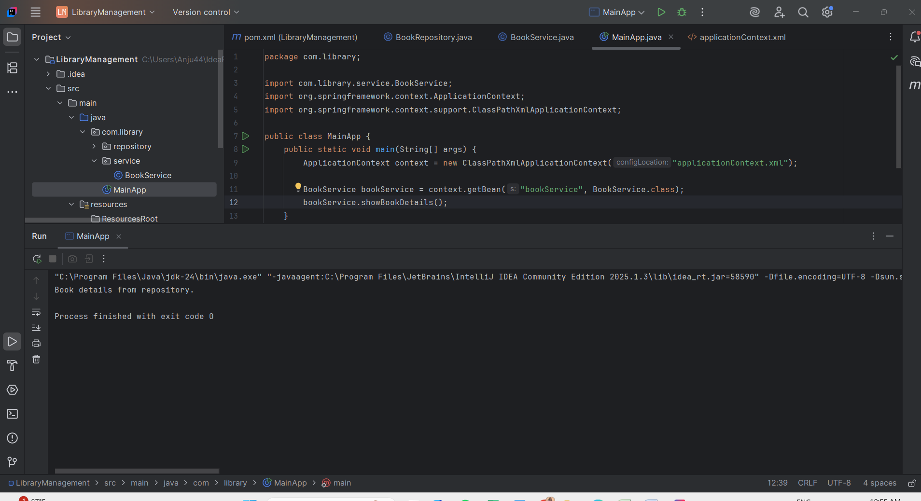

**Exercise 2: Implementing Dependency Injection**

**Scenario:**

In the library management application, you need to manage the dependencies between the BookService and BookRepository classes using Spring's IoC and DI.

Steps:

1. Modify the XML Configuration:

o Update applicationContext.xml to wire BookRepository into BookService.

2. Update the BookService Class:

o Ensure that BookService class has a setter method for BookRepository.

3. Test the Configuration:

o Run the LibraryManagementApplication main class to verify the dependency injection.

<?xml version="1.0" encoding="UTF-8"?>

<beans xmlns="http://www.springframework.org/schema/beans"

xmlns:xsi="http://www.w3.org/2001/XMLSchema-instance"

xsi:schemaLocation="

http://www.springframework.org/schema/beans

https://www.springframework.org/schema/beans/spring-beans.xsd">

<!-- Define Repository Bean -->

<bean id="bookRepository" class="com.library.repository.BookRepository"/>

<!-- Define Service Bean and Inject Repository -->

<bean id="bookService" class="com.library.service.BookService">

<property name="bookRepository" ref="bookRepository"/>

</bean>

</beans>

**MainApp.java:**

package com.library;

import com.library.service.BookService;

import org.springframework.context.ApplicationContext;

import org.springframework.context.support.ClassPathXmlApplicationContext;

public class MainApp {

public static void main(String[] args) {

ApplicationContext context = new ClassPathXmlApplicationContext("applicationContext.xml");

BookService bookService = context.getBean("bookService", BookService.class);

bookService.showBookDetails();

}

}

**Output:**

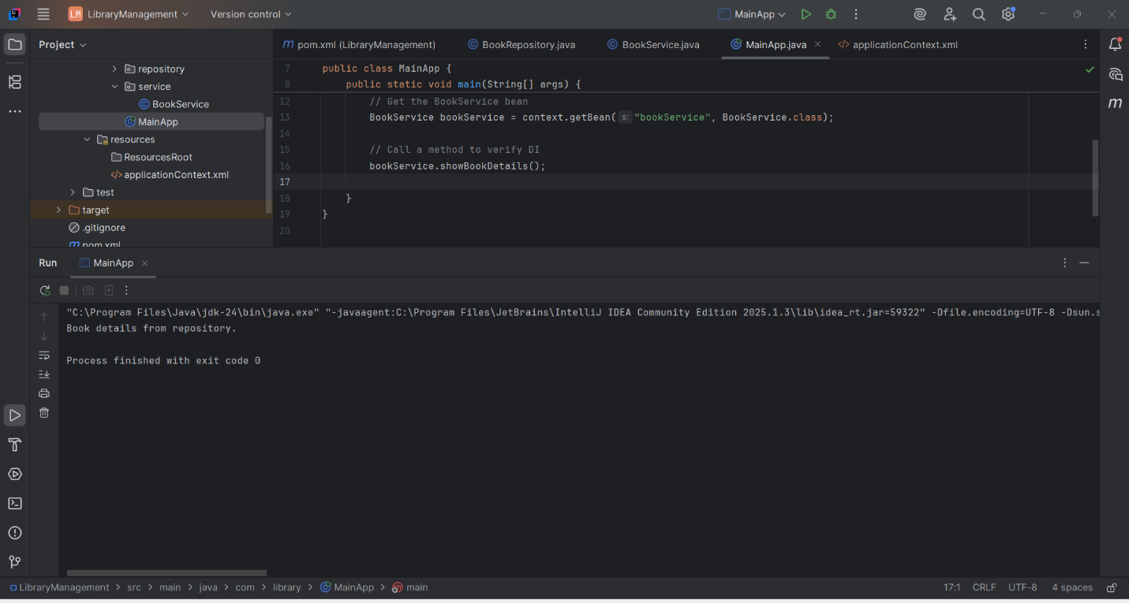

**Exercise 4: Creating and Configuring a Maven Project**

**Scenario:**

You need to set up a new Maven project for the library management application and add Spring dependencies.

Steps:

1. Create a New Maven Project:

o Create a new Maven project named LibraryManagement.

2. Add Spring Dependencies in pom.xml:

o Include dependencies for Spring Context, Spring AOP, and Spring WebMVC.

3. Configure Maven Plugins:

o Configure the Maven Compiler Plugin for Java version 1.8 in the pom.xml file.

<project xmlns="http://maven.apache.org/POM/4.0.0"  
 xmlns:xsi="http://www.w3.org/2001/XMLSchema-instance"  
 xsi:schemaLocation="http://maven.apache.org/POM/4.0.0  
 https://maven.apache.org/xsd/maven-4.0.0.xsd">  
 <modelVersion>4.0.0</modelVersion>  
 <groupId>com.library</groupId>  
 <artifactId>LibraryManagement</artifactId>  
 <version>1.0-SNAPSHOT</version>  
 <properties>  
 <maven.compiler.source>1.8</maven.compiler.source>  
 <maven.compiler.target>1.8</maven.compiler.target>  
 <project.build.sourceEncoding>UTF-8</project.build.sourceEncoding>  
 </properties>  
 <dependencies>  
 <!-- Spring Core Context -->  
 <dependency>  
 <groupId>org.springframework</groupId>  
 <artifactId>spring-context</artifactId>  
 <version>5.3.30</version>  
 </dependency>  
 <!-- Spring AOP -->  
 <dependency>  
 <groupId>org.springframework</groupId>  
 <artifactId>spring-aop</artifactId>  
 <version>5.3.30</version>  
 </dependency>  
 <!-- Spring WebMVC -->  
 <dependency>  
 <groupId>org.springframework</groupId>  
 <artifactId>spring-webmvc</artifactId>  
 <version>5.3.30</version>  
 </dependency>  
 <!-- Servlet API (required for WebMVC) -->  
 <dependency>  
 <groupId>javax.servlet</groupId>  
 <artifactId>javax.servlet-api</artifactId>  
 <version>4.0.1</version>  
 <scope>provided</scope>  
 </dependency>  
 </dependencies>  
 <build>  
 <plugins>  
 <plugin>  
 <groupId>org.apache.maven.plugins</groupId>  
 <artifactId>maven-compiler-plugin</artifactId>  
 <version>3.8.1</version>  
 <configuration>  
 <source>1.8</source>  
 <target>1.8</target>  
 </configuration>  
 </plugin>  
 </plugins>  
 </build>  
</project>

**Output:**

